The Butterflies of Yonkers
Swallowtails  ___ Pipevine Swallowtail  ___ Black Swallowtail  ___ Giant Swallowtail  ___ Eastern Tiger Swallowtail  ___ Spicebush Swallowtail  Whites  ___ Cabbage White  Sulphurs  ___ Clouded Sulphur  ___ Orange Sulphur  ___ Cloudless Sulphur (rare)  ___ Little Yellow (rare)  Coppers  ___ American Copper  Hairstreaks  ___ Coral Hairstreak  ___ Banded Hairstreak  ___ Hickory Hairstreak  ___ Striped Hairstreak  ___ Red-banded Hairstreak  ___ White M Hairstreak  ___ Gray Hairstreak  Blues  ___ Eastern Tailed Blue  ___ Spring Azure  ___ Summer Azure  Fritillaries  ___ Variegated Fritillary (rare)  ___ Great Spangled Fritillary  ___ Aphrodite Fritillary (rare)  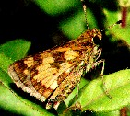  Peck's Skipper | True Brush-foots  ___ Silvery Checker Spot  ___ Pearl Crescent  ___ Question Mark  ___ Eastern Comma  ___ Mourning Cloak  ___ Compton Tortoiseshell  ___ American Lady  ___ Painted Lady  ___ Red Admiral  ___ Common Buckeye  Admirals and Relatives  ___ Red-spotted Purple  Satyrs  ___ Little Wood I Satyr  ___ Little Wood II Satyr  ___ Common Ringlet  Monarchs  ___ Monarch  Spread-winged Skippers  ___ Silver-spotted Skipper  ___ Long Tailed Skipper (rare)  ___ Hoary Edge  ___ Northern Cloudywing  ___ Dreamy Duskywing  ___ Juvenal's Duskywing  ___ Horace's Duskywing  ___ Wild Indigo Duskywing  ___ Common Checkered Skipper  ___ Common Sootywing  Grass Skippers  ___ Least Skipper  ___ European Skipper  ___ Fiery Skipper (rare)  ___ Peck's Skipper  ___ Tawny-edged Skipper  ___ Crossline Skipper  ___ Northern Broken Dash  ___ Little Glassywing  ___ Sachem (rare)  ___ Delaware Skipper  ___ Hobomok Skipper  ___ Zabulon Skipper  ___ Broad-winged Skipper  ___ Dun Skipper | 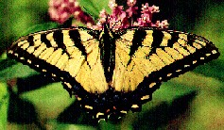  Eastern Tiger Swallowtail  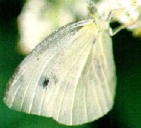  Cabbage White  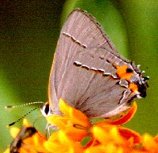  Gray Hairstreak  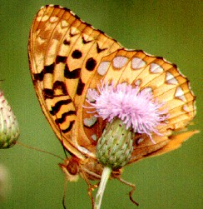  Great Spangled Fritillary

